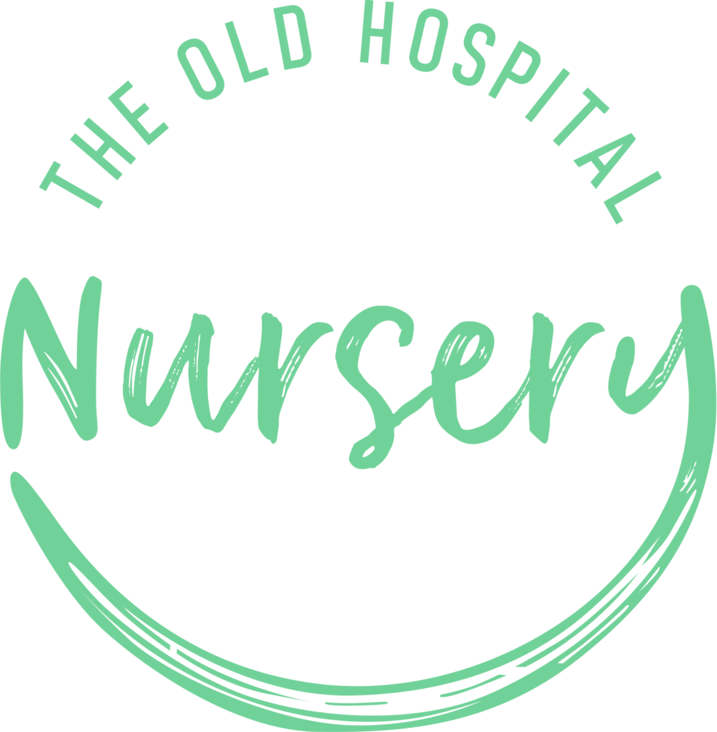

Admissions Policy

EYFS: 3.25, 3.45, 3.51, 3.52

Date of Last Review: 06/10/2023
Date for Next Review: 06/10/2025 (unless legislation changes)
Trigger is In Place For Next Review

At Childwise Nursery we care for 17 children between the ages of 0-5

The numbers and ages of children admitted to the nursery comply with the legal space requirements set out in the Early Years Foundation Stage (EYFS).

We take the following matters into account when prioritising and deciding on admissions:

- Availability of places, taking into account the staff: child ratios, the age of the child and any registration requirements
- Children who have siblings who are already with us
- When the application is received (extra weight is given to those who have been on the waiting list the longest)
- The nursery's ability to provide the facilities necessary for the welfare of the child, including appropriate staffing arrangements
- A child requiring a full-time place may have preference over one requiring a part-time place. This is dependent upon work commitments, occupancy and room availability
- Any extenuating circumstances affecting the child's welfare or the welfare of his/her family.

We operate an inclusion and equality policy and ensure that all children have access to nursery places and services irrespective of their gender, race, disability, religion or belief or sexual orientation of parents.

Prior to a child attending nursery, parents must complete and sign a contract and registration form. These forms provide the nursery with personal details relating to the child. For example, name, date of birth, address, emergency contact details, parental responsibilities, dietary requirements, fees and sessions, contact details for parents, doctor s contact details, health visitor contact details, allergies, parental consent and vaccinations etc.

Providers eligible to provide government funded places for early education
All settings registered to accept government funding (detailed in the code of practice) must offer free places for two to five year olds for early learning sessions specified by the local authority. We currently provide free funded places available for children subject to availability. Please note for admissions for the free nursery education we have a termly intake, beginning the term following your child's second or third birthday.

All funded sessions are now in line with the flexible arrangement as specified by the Government. When you register your child for their funded place we will discuss your needs and, as far as possible with availability and staffing arrangements, we will accommodate your wishes.

3, The Old Hospital, Field Stile Road, Southwold, IP18 6LD

