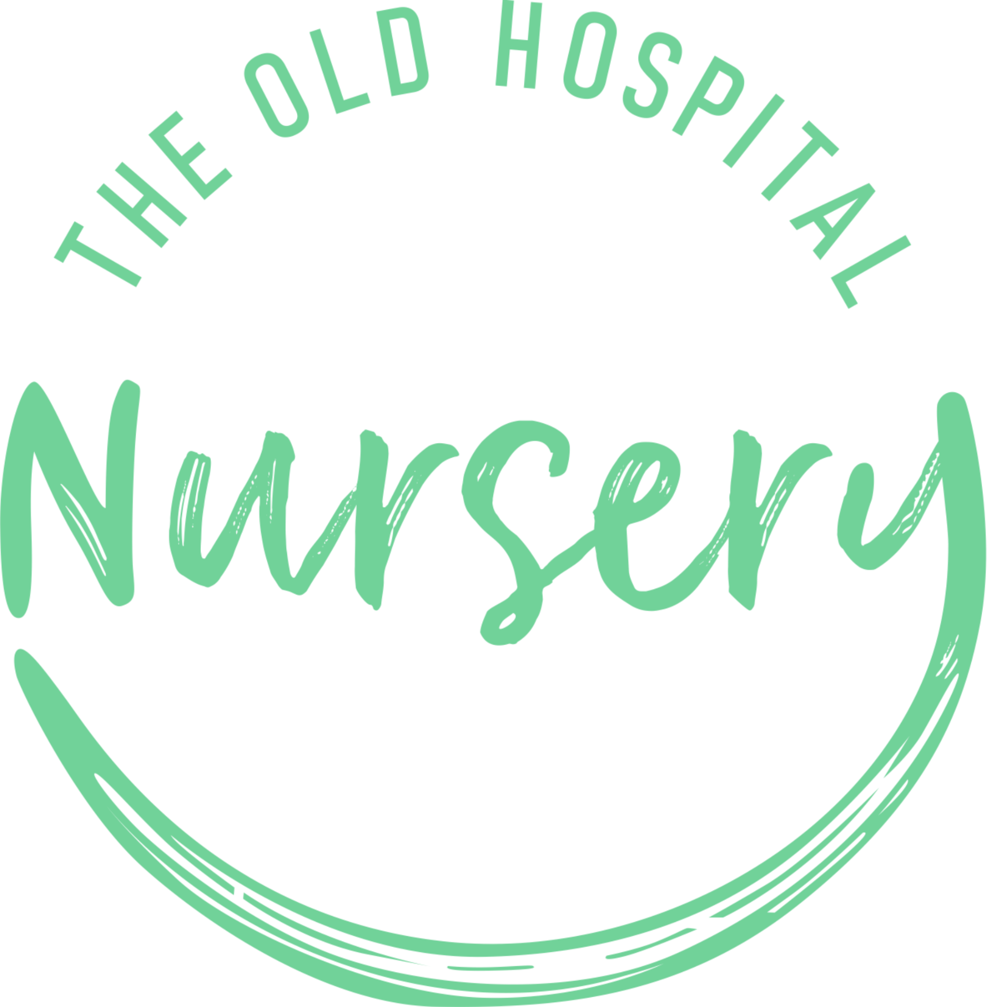
Sickness and Illness Policy

EYFS: 3.45, 3.46, 3.47, 3.48

Date of Last Review: 06/10/2023
Date for Next Review: 06/10/2025 (unless legislation changes)
Trigger is In Place For Next Review
3, The Old Hospital, Field Stile Road, Southwold, Suffolk, IP18 6LD.

At The Old Hospital Nursery we promote the good health of all children attending including oral health by:

- Asking parents to keep children at home if they are unwell. If a child is unwell, it is in their best interest to be in a home environment rather than at nursery with their peers.
- Asking staff and other visitors not to attend the setting if they are unwell
- Helping children to keep healthy by providing balanced and nutritious snacks, meals and drinks
- Minimising infection through our rigorous cleaning and hand washing processes (see infection control policy) Ensuring children have regular access to the outdoors and having good ventilation inside
- Sharing information with parents about the importance of the vaccination programme for young children to help protect them and the wider society from communicable diseases
- Sharing information from the Department of Health that all children aged 6 months – 5 years should take a daily vitamin
- Having areas for rest and sleep, where required and sharing information about the importance of sleep and how many hours young children should be having.

Our procedures
In order to take appropriate action of children who become ill and to minimise the spread of infection we implement the following procedures:
- If a child becomes ill during the nursery day, we contact their parent(s) and ask them to pick up their child as soon as possible. During this time, we care for the child in a quiet, calm area with their key person (wearing PPE), wherever possible
- We follow the guidance published by Public Health England (Health Protection in Schools and other childcare facilities) and advice from our local health protection unit on exclusion times for specific illnesses, e.g. sickness and diarrhoea, measles and chicken pox, to protect other children in the nursery
- Should a child have an infectious disease, such as sickness and diarrhoea, they must not return to nursery until they have been clear for at least 48 hours
- We inform all parents if there is a contagious infection identified in the nursery, to enable them to spot the early signs of this illness. We thoroughly clean and sterilise all equipment and resources that may have come into contact with a contagious child to reduce the spread of infection
- We notify Ofsted as soon as is reasonably practical, but in any event within 14 days of the incident of any food poisoning affecting two or more children cared for on the premises.
- We ask parents to keep children on antibiotics at home for the first 48 hours of the course (unless this is part of an ongoing care plan to treat individual medical conditions e.g. asthma and the child is not unwell) This is because it is important that children are not subjected to the rigours of the nursery day, which requires socialising with other children and being part of a group setting, when they have first become ill and require a course of antibiotics
- We have the right to refuse admission to a child who is unwell. This decision will be taken by the manager on duty and is non-negotiable
- We make information/posters about head lice readily available and all parents are requested to regularly check their children’s hair. If a parent finds that their child has head lice we would be grateful if they could inform the nursery so that other parents can be alerted to check their child’s hair.

Meningitis procedure
If a parent informs the nursery that their child has meningitis, the nursery manager will contact the Local Area Infection Control (IC) Nurse. The IC Nurse will give guidance and support in each individual case. If parents do not inform the nursery, we may be contacted directly by the IC Nurse and the appropriate support given. We will follow all guidance given and notify any of the appropriate authorities including Ofsted where necessary.

We will follow the transporting children to hospital procedure in any cases where children may need hospital treatment.
The nursery manager/staff member must:
• Inform a member of the management team immediately
- Call 999 for an ambulance immediately if the illness is severe. DO NOT attempt to transport the unwell child in your own vehicle
- Follow the instructions from the 999 call handler
- Whilst waiting for the ambulance, a member of staff must contact the parent(s) and arrange to meet them at the hospital
- Redeploy staff if necessary to ensure there is adequate staff deployment to care for the remaining children. This may mean temporarily grouping the children together
- Arrange for the most appropriate member of staff to accompany the child taking with them any relevant information such as registration forms, relevant medication sheets, medication and the child’s comforter
- Remain calm at all times. Children who witness an incident may well be affected by it and may need lots of cuddles and reassurance. Staff may also require additional support following the accident.

Non Emergency Transport

We will not provide transport to a hospital in a non emergency situation. We will endeavour to keep the child comfortable, warm and safe until the parent/guardian arrives or designated other adult with parent permission to take the child to hospital or the child’s doctor.

This policy will be reviewed at least annually in consultation with staff and parents and/or after a significant incident, e.g. serious illness/hospital visit required.

https://www.gov.uk/government/publications/health-protection-in-schools-and-other-childcare-facilities

